**EAST WEST UNIVERSITY**

**Project Report**

Project Title: Rock paper Scissor

Course Code: CSE105

Course Title: Structure Programming  
Section: 04

**Submitted by:**

Sk Mohammad Asem

ID:2017-3-60-068

Sharika Tasnim Arshi

ID:2017-3-60-084

Sayed Shafa

ID:2017-3-60-016

Nazibullah MD Aynan

ID:2017-3-60-073

**Submitted to:**

Dr. Taskeed Jabid

Associate Professor,

Department of Computer Science & Engineering,

East West University

Date of Submission: 15 September 2022

**Introduction:** Rock Paper Scissor is a hand game and played  by two individuals while simultaneously forming one of three shapes. According to the following regulations, the game's winner is determined:

* Rock vs Paper -> Paper wins.
* Rock vs Scissor -> Rock wins.
* Paper vs Scissor -> Scissor wins.

In this game, the user will be ask to make a decision. The decision made by the user and the computer will determine the outcome, which will be displayed along with the user and computer's choices.

**Methodology:** Here we try to discuss our entire gaming process. At first we discussed about user end and computer vice versa.

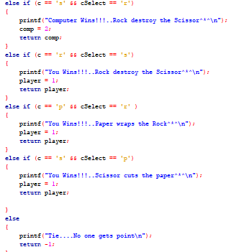

Then secondly we discussed how to save scores  in a file. Game score will be stored in a file when the old score is less than the new score. If the old score is greater than the new score then the file will show the old score.

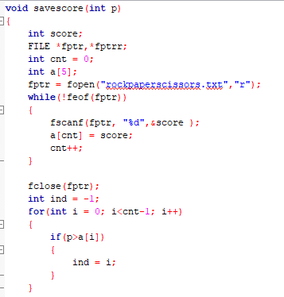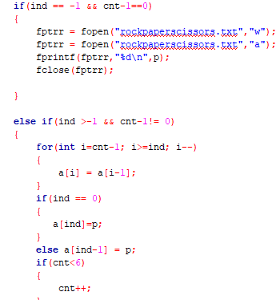

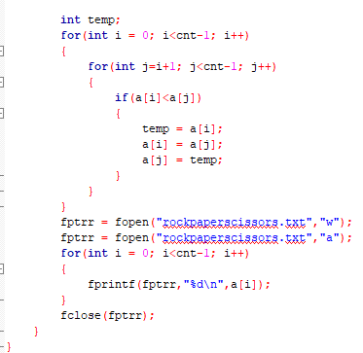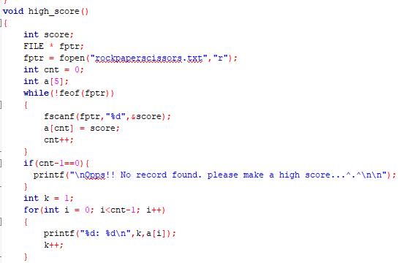

**Flow Chart:** Rock Paper & scissor game

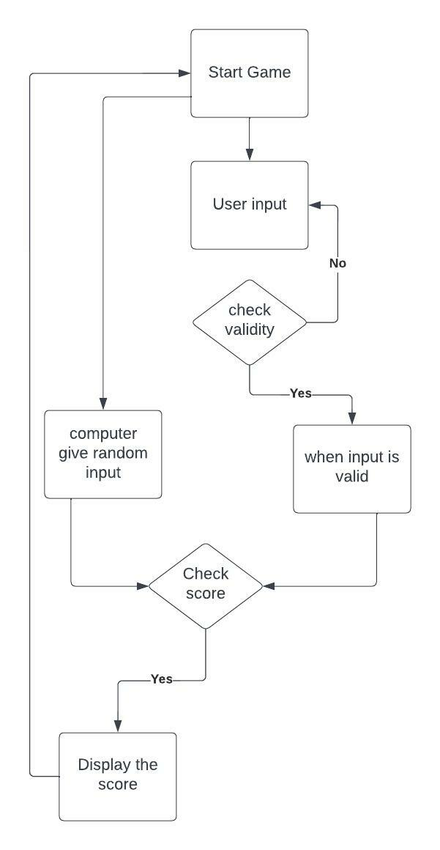

**Result Analysis**:  Here, at first the user have to  choose any of these  three options.

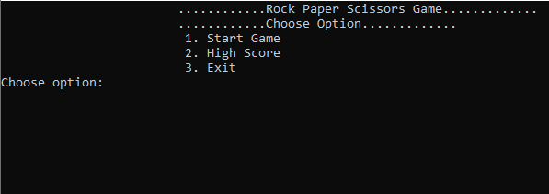

If the user choose option 1 then the game will start.

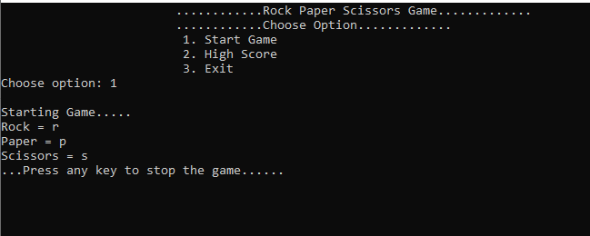

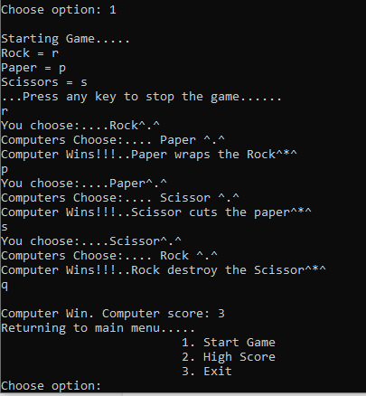

If the user wants to quit the game then he/she have to press any input from keyboard except r, p & s. If user wants to check the score; he/she have to choose option 2.

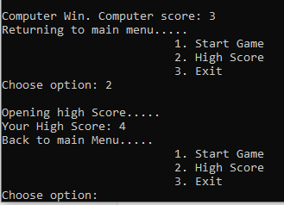

**Conclusion:** A surprising number of people take the game of rock-paper-scissors quite seriously. Due to the fact that a tie happens around 1/3 of the time, several variants of Rock-Paper-Scissors exist that include more choices to make ties more unlikely. In this project we had try our best more user friendly in rock paper scissor game.